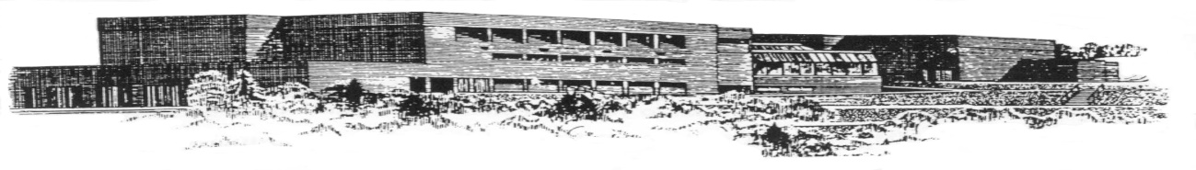
DALHOUSIE REGIONAL HIGH SCHOOL
500 CANADA GAMES DRIVE
DALHOUSIE, N.B.
E8C 2P5

TELEPHONE: (506) 684-7553 PRINCIPAL: Ms. Lori Johnson
FAX: (506)684-7602 VICE-PRINCIPAL: Kathy Parker

School Lunch Program – Launch Update
Dear Parents/Guardians,
We want to let families know that the launch of the School Lunch Program at Dalhousie Regional High School will be delayed as final preparations are completed.
The school’s lunch provider is actively working to prepare for the start of service and to ensure they are fully ready to provide students with consistent, high-quality lunch service when the program begins.

What happens next?
As soon as the provider is ready to launch, families will be contacted with the information needed to register and begin ordering lunches. This will include:
- Registration and online ordering instructions
- Information about menus and meal options
- Ordering and payment information
- Information about available financial support
- The confirmed date that lunch service will begin at your school
There is no action required from families at this time.
We look forward to welcoming your family to the School Lunch Program and providing students with access to healthy, affordable lunches at school.
For questions related to the School Lunch Program, please contact SchoolLunchProgram-programmededinersscolaires@gnb.ca.
Lori Johnson
Principal

