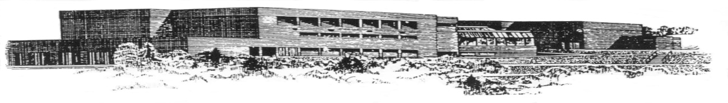
DALHOUSIE REGIONAL HIGH SCHOOL
500 CANADA GAMES DRIVE
DALHOUSIE, N.B.
E8C 2P5

TELEPHONE: (506) 684-7553 PRINCIPAL: Lori Johnson
FAX: (506)684-7602 VICE-PRINCIPAL: Kathy Parker

School Lunch Program – Launch Update
Dear Parents/Guardians,

We are pleased to share information about the new Provincial School Lunch Program, launching in schools across New Brunswick on September 8, 2026.

Through the program, families can purchase nutritious school lunches for their children at a reduced cost.

Your school’s lunch provider is Chartwells.

Lunches will be available on school days. A regular option and a vegetarian option will be offered each day. Milk will be included with every lunch. Lunches will be available to all students; however, participation is optional and families are not required to order.

Participating families will pay:
· $4 per meal for kindergarten to Grade 8
· $5 per meal for Grades 9 to 12

The Provincial School Lunch Program will subsidize the remaining cost of each lunch.

DRHS online ordering will begin Monday, September 14th. Chartwells will begin service on Wednesday, September 16th. Orders must be placed 24 hours in advance.

Please use the following link to create an account for your child/children -Chartwells registering and ordering

If paying for school lunches is a barrier for your family, please contact the school at 506-684-7553. All requests will be handled confidentially. For more information, please consult the frequently asked questions section here School Food Programs

If you have general questions about the Provincial School Lunch Program, please contact SchoolLunchProgram-programmededinersscolaires@gnb.ca

We look forward to welcoming students to the School Lunch Program.
Sincerely,
Lori Johnson
Principal DRHS

